12.49: a) The simplest way to approach this problem is to find the force between the spacecraft and the center of mass of the earth-moon system, which is 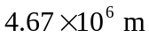from the center of the earth.

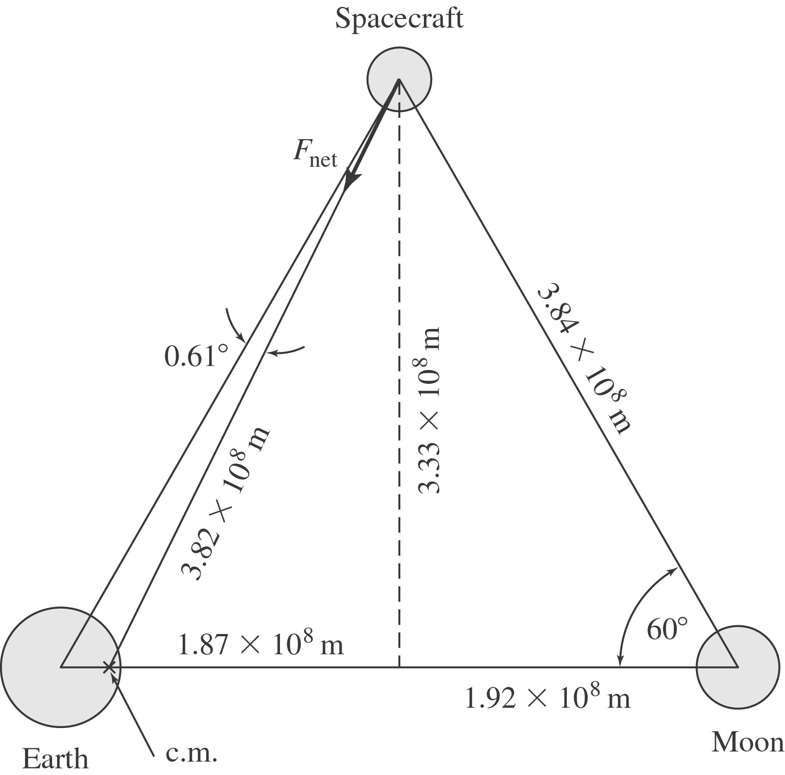
The distance from the spacecraft to the center of mass of the earth-moon system is 3.82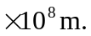 Using the Law of Gravitation, the force on the spacecraft is 3.4 N, an angle of 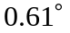from the earth-spacecraft line. This equilateral triangle arrangement of the earth, moon and spacecraft is a solution of the Lagrange Circular Restricted Three-Body Problem. The spacecraft is at one of the earth-moon system Lagrange points. The Trojan asteriods are found at the corresponding Jovian Lagrange points.
